THE II BOHDAN OSADCHUK SCHOOL - PROGRAMME
22 - 29 November 2015
The workshops and the lectures will take place in the Castle on the Water in Wojnowice, 2 Zamkowa St, and in Wrocław (in the Regional Center of International Debate , 17 Nankiera Sq).
Day 1 – Accommodation – Sunday, 22 November 2015
Arrival in Wrocław; accommodation in a hotel.
Day 2 – History Day - Monday, 23 November 2015 – time: 9:00-17:30
9:00 - Opening of the II Bohdan Osadchuk School.
9:15 – 10:45 - Opening lecture „History of XX c. – history of Bohdan Osadchuk”
11:00 – 12:30 History Workshop – „Dfficult history or just history?”
The idea of workshop is not only to discuss difficult history of three nations: Ukrainian, German and Polish, but also to show similar examples from other parts of the world like history of relations of former Yugoslavia nations or Anglo-Irish relations etc.
12:45 – 13:45 Lunch break.
14:00 – 15:30 Lecture – „We, you, and they – history and nations history”.
The idea of the lecture is to compare the view on specific events through history as international academic discipline and history as a tool of telling your own nation past.
16:00 – 17:30 Workshops – „Common language or Tower of Babel – is it possibile to have a common history handbook?”
The idea of workshop is to discuss the possibility of making a common history handbook – starting with a Ukrainian-German-Polish handbook. And maybe in the future a European and a universal handbook.

Regional Center of International Debate , 17 Nankiera Sq
Day 3 – Ukrainian Day, Tueasday, 24 November 2015 - time: 9:00-20:00
Lectures, workshops and seminars focused on culture, history and politics of modern Ukraine – especially those which are currently under public discussion. The main part of the day, especially that focused on culture and history, will be prepared and led by the Ukrainian participants of the Osadchuk School.
9:00 – 10:30 Opening lecture about modern Ukraine (given by Ukrainian group Mentor)
10:45 – 12:15 Seminar – „Top stories: Ukraine – what do we discuss on politics and history?”
The whole seminar will be prepared by the Osadchuk School participants from Ukraine. The main subject will be top stories in Ukraine connected to politics and history. The seminar will have a form of a lecture and an open discussion.
12:15 – 13:30 Lunch break
13:45 – 15:15 „School Reading List Books: Ukraine –what do shape us?”
The whole seminar will be prepared by the Osadchuk School participants from Ukraine. The main subject will be the most important school reading books that shape students in modern Ukraine. The seminar will have a form of a lecture and an open discussion.
15:30 – 17:30 Workshop - „What next? Ukraine?”
Workshops in form of an open discussion moderated by a Mentor. The main subject will the future of Ukraine – possible development directions, future plans and possible problems. All topics will be discussed as viewed by Ukrainians and also Poles and Germans.
18:00 – 20:00 – Ukrainian film screening and discussion – the title chosen by Ukrainian participants.
Castle on the Water in Wojnowice, 2 Zamkowa St
Day 4 – Polish Day - – 25 November 2015 - time: 9:00-20:00
Lectures, workshops and seminars focused on culture, history and politics of modern Poland – especially those which are currently under public discussion. Main part of the day, especially that focused on culture and history, will be prepared and led by the Polish participants of the Osadchuk School.
9:00 – 10:30 Opening lecture about modern Poland (given by Polish group Mentor)
10:45 – 12:15 Seminar – „Top stories: Poland – what do we discuss on politics and history?”
Whole seminar will be prepared by the Osadchuk School participants from Poland. The main subject will be top stories in Ukraine connected to politics and history. The seminar will have a form of a lecture and an open discussion.
12:15 – 13:30 Lunch break.
13:45 – 15:15 „School Reading List Books: Poland – what does shape us?”
Whole seminar will be prepared by the Osadchuk School participants from Poland. The main subject will be the most important school reading books that shape students in modern Poland. The seminar will have a form of a lecture and an open discussion.
15:30 – 17:30 Workshop - „What next? Poland?”
Workshops in form of an open discussion moderated by a Mentor. The main subject will the future of Poland – possible development directions, future plans and possible problems. All topics will be discussed as viewed by Poles and also Ukrainians and Germans.
18:00 – 20:00 – Polish film screening and discussion – the title chosen by Polish participants.
Castle on the Water in Wojnowice, 2 Zamkowa St
Day 5 – German Day, Thursday – 26 November 2015 - time: 9:00-20:00
Lectures, workshops and seminars focused on culture, history and politics of modern Germany – especially those which are currently under public discussion. Main part of the day, especially that focused on culture and history, will be prepared and led by the German participants of the Osadchuk School.
9:00 – 10:30 Opening lecture about modern Germany (given by German group Mentor)
10:45 – 12:15 Seminar – „Top stories: Germany – what do we discuss on politics and history?”
The whole seminar will be prepared by the Osadchuk School participants from Germany. The main subject will be top stories in Germany connected to politics and history. The seminar will have a form of a lecture and an open discussion.
12:15 – 13:30 Lunch break
13:45 – 15:15 „School Reading List Books: Germany – what does shape us?”
Whole seminar will be prepared by the Osadchuk School participants from Germany. The main subject will be the most important school reading books that shape students in modern Germany. The seminar will have a form of lecture and open discussion.
15:30 – 17:30 Workshop - „What next? Germany?”
Workshops in form of open discussion moderated by Mentor. The main subject will the future of Germany – possible development directions, future plans and possible problems. All topics will be discussed as viewed by Germans and also Poles and Ukrainians.

18:00 – 20:00 – German film screening and discussion – the title chosen by German participants.
Castle on the Water in Wojnowice, 2 Zamkowa St
Day 6 – Media day, Friday – 27 November 2015 - time: 9:00-19:00
9:30 – 10:45 Lecture - „Opinions, facts or speculation? How media create an image of states and nations with an example of Ukraine, Germany and Poland.
11:00 – 12:30 Workshop – „Social media – unlimited truth or Joseph Goebbels dream?”
12:30 – 16:30 Lunch break and sightseeing.
17:00 – 19:00 Debate on Polish-German-Ukrainian relations.
Regional Center of International Debate , 17 Nankiera Sq
Day 7 – Day of summaries, Saturday – 28 November 2015 - time: 9:00-16:00
The day is focused on summaries of the whole project. Participants together with trainers once again will discuss most important topics from the past five days – culture, history, politics and media.
9:00 – 10:30 Workshops – „Wrocław, Breslau, Vratislavia. Lwów, Lviv, Lemberg. How to build good relations between nations - example of two cities.”
10:45 – 12:15 Seminar – „In conclusion… The most important topics between three nations – discussion on II Bohdan Osadchuk School”
12:15 – 13:15 Lunch break.
14:45 – 15:45 Lecture from a member of the Foundation for Polish-German Cooperation.
app.16:00 II Bohdan Osadchuk School Closing Ceremony.
Castle on the Water in Wojnowice, 2 Zamkowa St
Day 8 – Day of departures, Sunday – 29 November 2015
Last Day, when participants can check-out from the hotel; departures from Wrocław.

The project is co-financed by the Foundation for Polish-German Cooperation
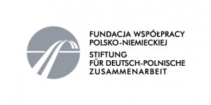
The project is co-financed by the Polish-American Freedom Foundation program "Study Tours to Poland"
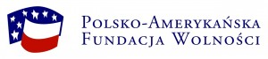
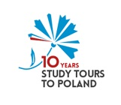
Organizer:
The Jan Nowak-Jeziorański College of Eastern Europe in Wrocław
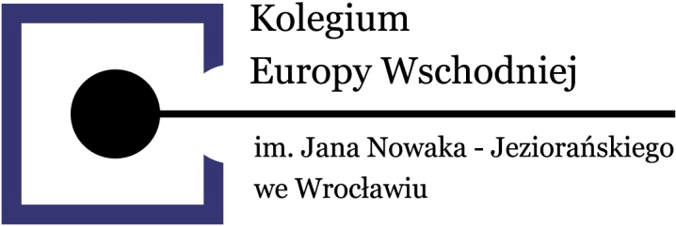

Partners:

German Culture Forum for Eastern Europe
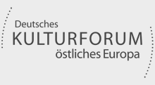

New Eastern Europe

Regional Centre for International Debate in Wrocław
